

REPORT ON HANGMAN GAME

PYTHON PROGRAMMING

____________________________________________

NAME : AYUSH SINGH

REGISTRATION NUMBER : 12107173

NAME :MD SAKEEL

REGISTRATION NUMBER :12107443

NAME :DEVDAN KUNDU

REGISTRATION NUMBER :12107188

____________________________________________

**INTRODUCTION**

Python Programming language Python is one of the many open source object oriented programming application software available in the market . Python is developed by Guido van Rossum. Guido van Rossum started implementing Python in 1989. Python is a very simple programming language so even if you are new to programming, you can learn python without facing any issues. Some of the many uses of Python are application development, implementation of automation testing process, allows multiple programming build, fully constructed programming library, can be used in all the major operating systems and platforms, database system accessibility, simple and readable code, easy to apply on complex software development processes, aids in test driven software application development approach, machine learning/ data analytics, helps pattern recognitions, supported in multiple tools, permitted by many of the provisioned frameworks, etc.

1. Readable: Python is a very readable language.

2. Easy to Learn: Learning python is easy as this is a expressive and high level programming language, which means it is easy to understand the language and thus easy to learn.

3. Cross platform: Python is available and can run on various operating systems such as Mac, Windows, Linux, Unix etc. This makes it a cross platform and portable language.

4. Open Source: Python is a open source programming language.

5. Large standard library: Python comes with a large standard library that has some handy codes and functions which we can use while writing code in Python.

6. Free: Python is free to download and use. This means you can download it for free and use it in your application. See: Open Source Python License. Python is an example of a FLOSS (Free/Libre Open Source Software), which means you can freely distribute copies of this software, read its source code and modify it.

7. Supports exception handling: If you are new, you may wonder what is an exception? An exception is an event that can occur during program exception and can disrupt the normal flow of program. Python supports exception handling which means we can write less error prone code and can test various scenarios that can cause an exception later on.

8. Advanced features: Supports generators and list comprehensions. We will cover these features later.

9. Automatic memory management: Python supports automatic memory management which means the memory is cleared and freed automatically

**IMPLEMENTATION AND RESULTS**

About Project

This is a simple Hangman game using Python programming language and GUI concept. Beginners can use this as a small project to boost their programming skills and understanding logic.

1. The Hangman program randomly selects a secret word from a list of secret words. The random module will provide this ability, so line 1 in program imports it.

2. The Game: Here, a random word (a person’s name) is picked up from our collection and the player gets limited chances to win the game.

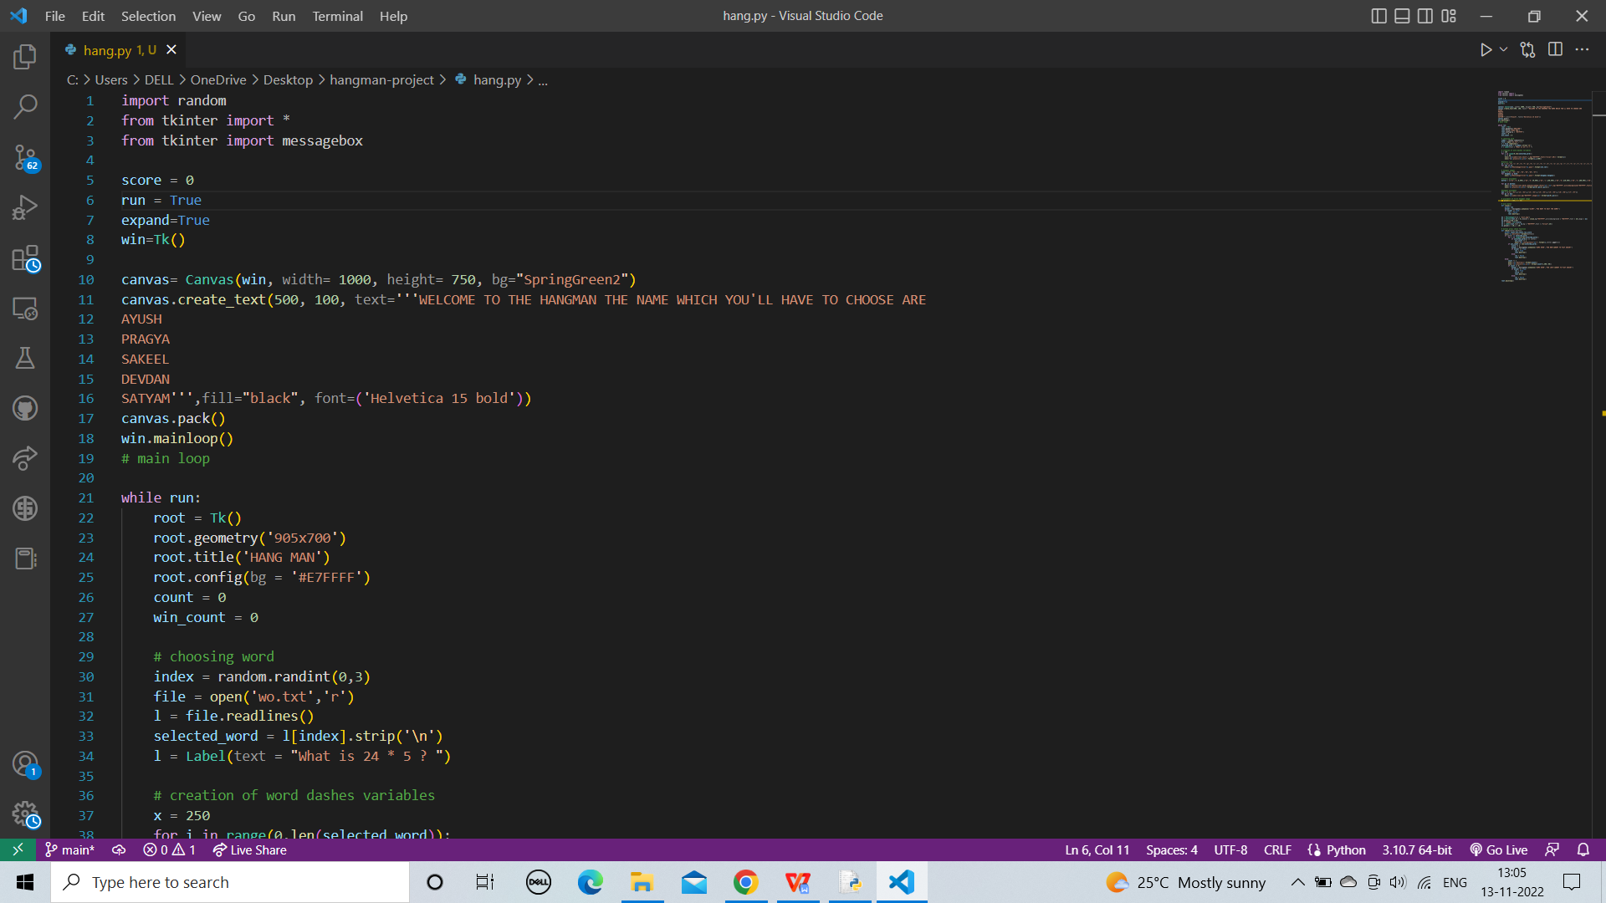

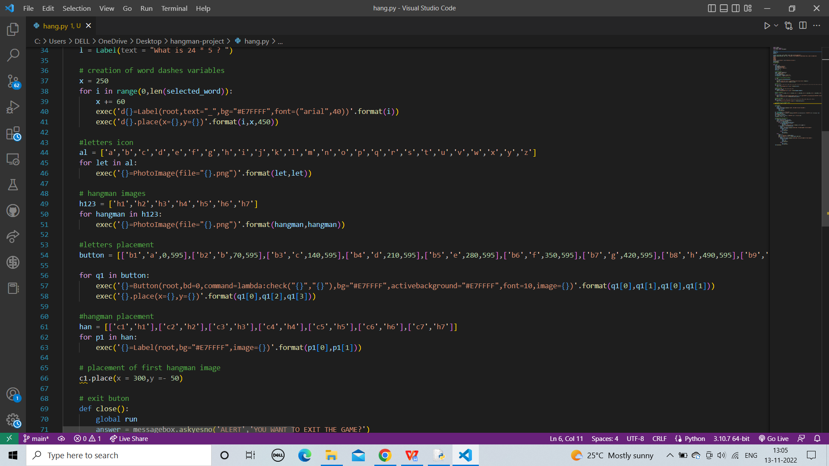

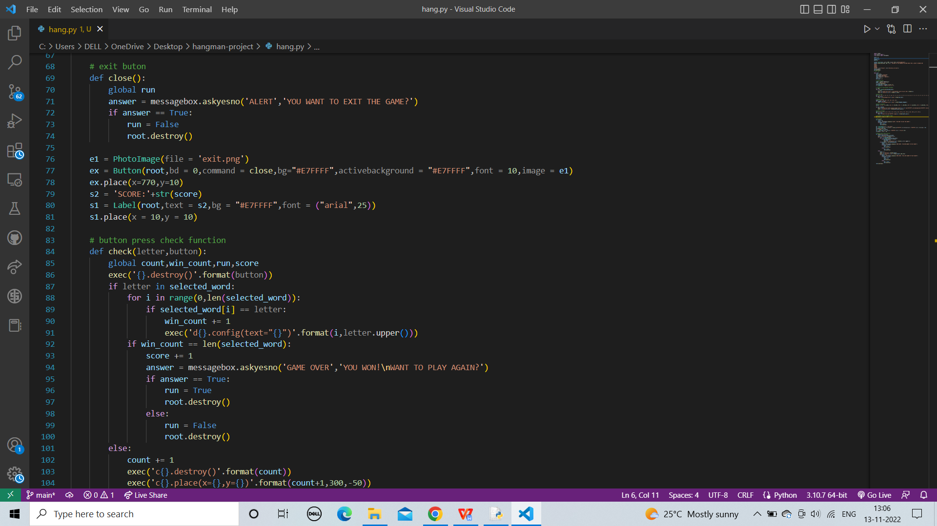

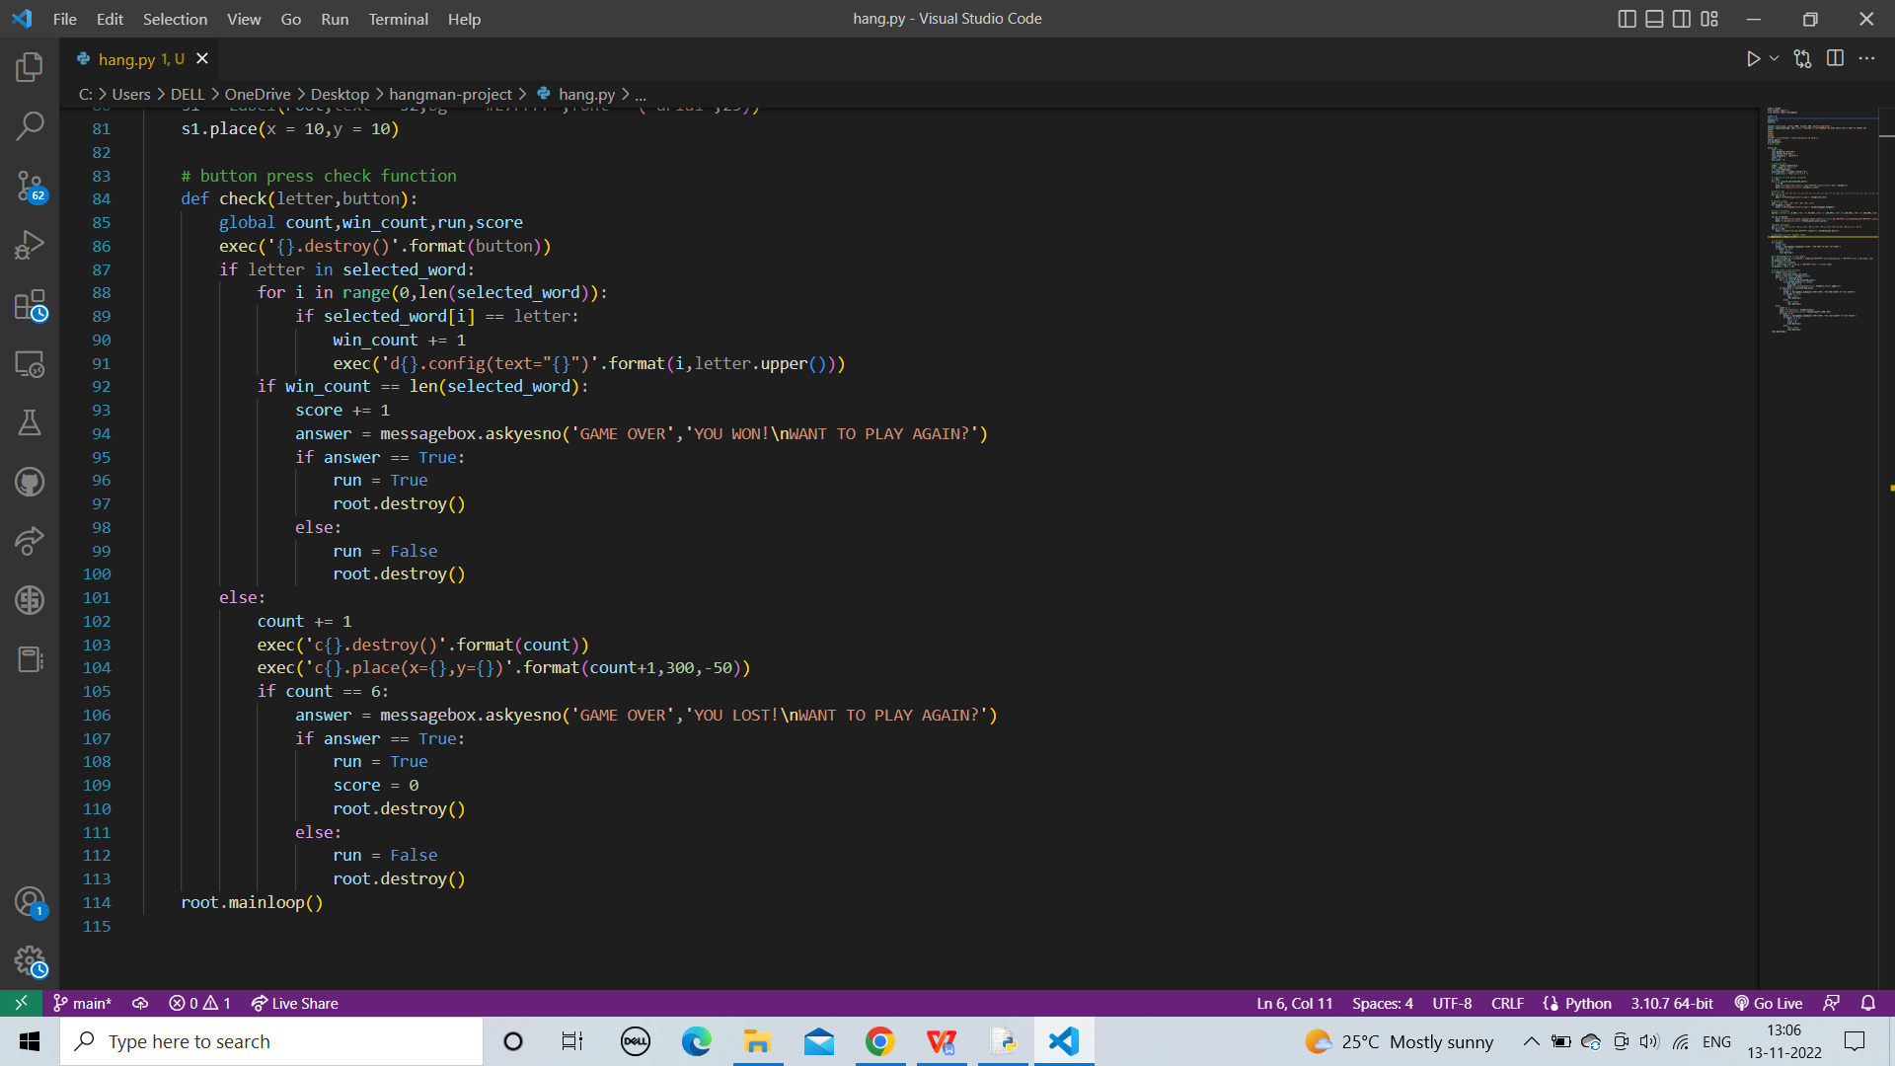

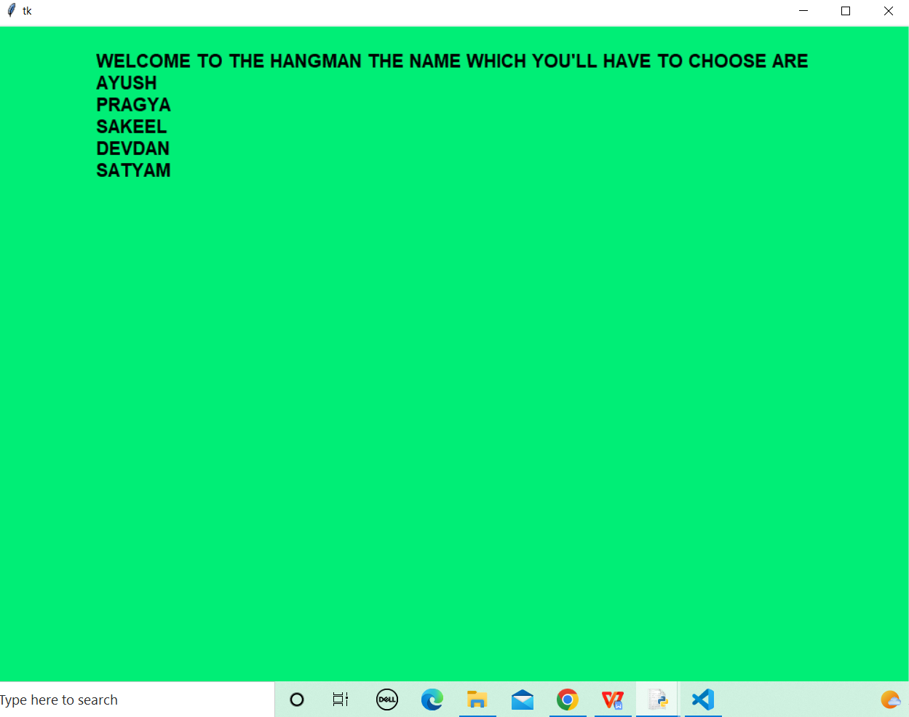

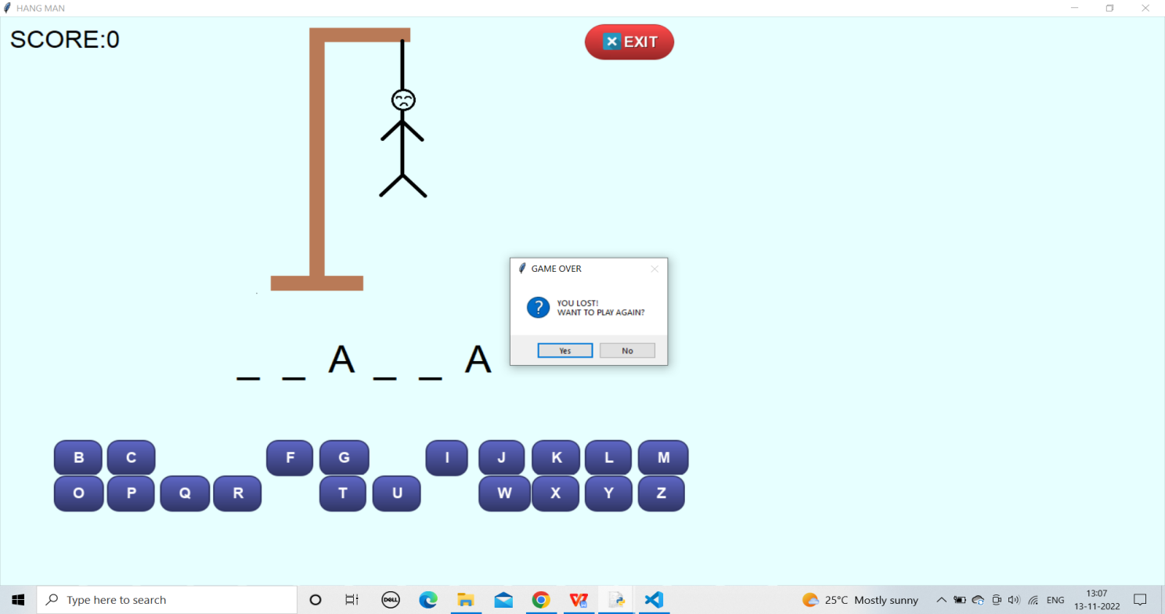

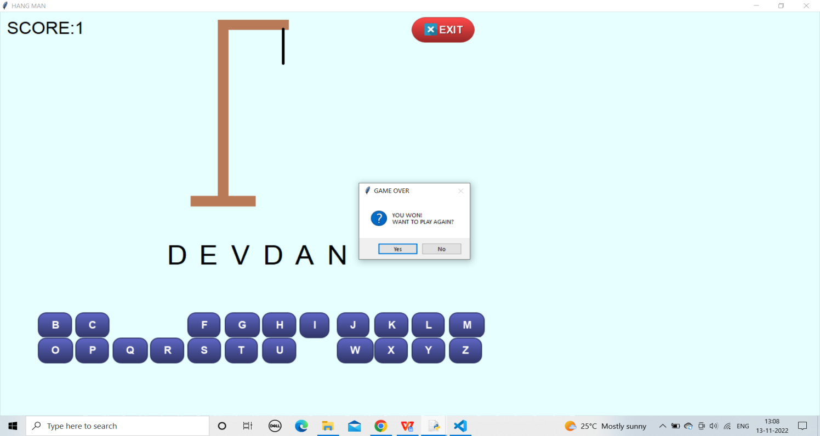

**CONCLUSION**

In the conclusion of this project, Hangman is a traditional game, typically played with words. It’s possible, however, to play Category Hangman rather than guessing words the player might guess names of cities, or athletes, or fictional characters, or Duke professors, or top forty song titles the list is endless. You’ll be writing a program to play a “guess a word letter-by-letter” version of hangman as shown above. You’ll also be doing some statistical analysis of the words used in the Hangman game.

**REFERENCES**

**Bibliography:**

[1] “Python for everybody”, Charles R.Severance

[2] “Think Python”, Allen B.Downey

[3]”Python programming”, Mark lutz

**Websites:**

[1]https://www.youtube.com/watch?v=QXeEoD0pB3E&list=PLsyeobzWxl7poL9JTVyndKe 6 2ieoN-MZ3

[2]https://www.youtube.com/watch?v=NKVOjPHfiSA

[3] https://www.youtube.com/watch?v=BDi3SD7E6no